「日・サウジアラビア外交関係樹立６０周年」
公式ロゴマークの決定

平成２６年７月４日
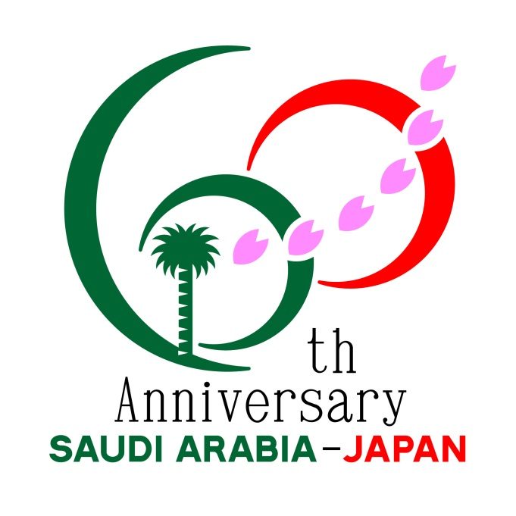

１ 今般，日・サウジアラビア両国政府間での協議の結果，「日・サウジアラビア外交関係樹立６０周年」の公式ロゴマークが，決定しました。
ロゴマークの一般公募に対し日本，サウジアラビア等から，７３点の応募がありました。このロゴマークは，２０１５年を通じ日本及びサウジアラビア王国で共通に使用します。

２ ロゴマークの作者は，奥野 和夫（おくの かずお）氏（グラフィックデザイナー／神奈川県在住）。新月（イスラム）と昇る太陽（日の丸）で「６０」の文字を描き，両国の象徴として「ヤシの木」と「桜吹雪」をあしらい，６０年の友好関係を表現しています。また，６枚の桜の花びらは６０年の歳月を意味します。

日・サウジアラビア外交関係樹立６０周年（２０１５年）記念事業認定申請について

Announcement of the Official Logo
for the 60th anniversary of the establishment of diplomatic relationship between Japan and the Kingdom of Saudi Arabia in 2015

July 4, 2014
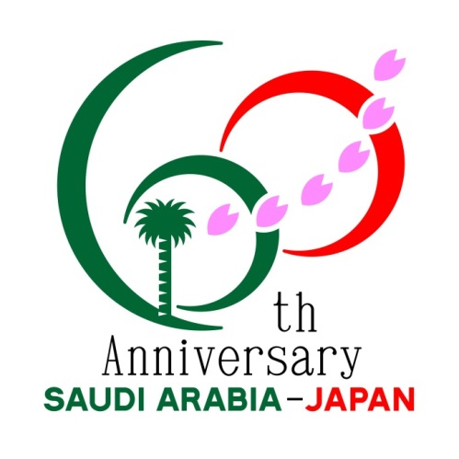
1. Details of entries and selection process
The official logo for "the 60th anniversary of the establishment of diplomatic relationship between Japan and the Kingdom of Saudi Arabia in 2015" was adopted by both the Governments of Japan and the Kingdom of Saudi Arabia. There were 73 entries for the logo from Japan, Saudi Arabia and other countries. This logo will be used in Japan and the Kingdom of Saudi Arabia through 2015.

2. Logo
The creator is Mr. Kazuo OKUNO, a Japanese graphic designer living in Kanagawa prefecture. This logo symbolizes both countries’ friendly relationship, with the number 60 being represented by both a crescent and a rising sun and the bilateral friendship of past 60 years being expressed by six cherry petals, while a palm tree and a flurry of falling cherry blossoms symbolize Saudi Arabia and Japan respectively.

Event Endorsement Guidelines for the 60th anniversary of the establishment of diplomatic relationship between Japan and the Kingdom of Saudi Arabia in 2015

